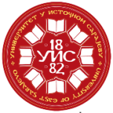 |  | UNIVERSITY OF EAST SARAJEVO |  |  |  |  |  |  |  |  |  | 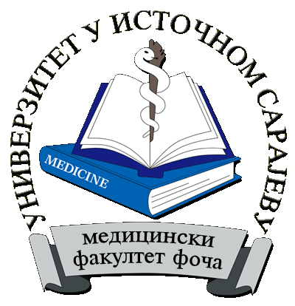
 |  | Study programme  /  module | Специјална едукација и рехабилитација  Speech therapy
II STUDY CYCLE
SUBJECTS |  |  |  | Lectures per week |  |  |  | Lectures per year |  |  | SSW | Total number of hours per subject | ECTS | The requirement for examination
 |  |  |  | I sem. |  | II sem.
No | Subject code | NAME OF SUBJECT |  | L | E | L | E | Lectures | Exercises | Total
1 | ДЛ -01-1-001-1 | Methodology of scientific research in special education and rehabitation |  | 2 | 2 | 0 | 0 | 30 | 30 | 60 | 120 | 180 | 6 | -
 |  | Elective subject I |  | 3 | 2 | 0 | 0 | 45 | 30 | 75 | 165 | 240 | 8 | -
 |  | Elective subject II |  | 3 | 2 | 0 | 0 | 45 | 30 | 75 | 165 | 240 | 8 | -
 |  | Elective subject III |  | 3 | 2 | 0 | 0 | 45 | 30 | 75 | 165 | 240 | 8 | -
ДЛ-01-1-008-1 |  | Study research work |  | 0 | 0 | 0 | 0 | 0 | 0 | - | 300 | 300 | 10
ДЛ-01-1-009-1 |  | Diploma paper (master's thesis) |  | 0 | 0 | 0 | 0 | 0 | 0 | - | 600 | 600 | 20
 | Total number of active teaching |  |  |  |  |  |  | 165 | 120 | 285 | 1515 | 1800 | 60
Elective subject I
(A student listens and takes exam of 1 elective subject which goes into total student workload))
4 | ДЛ -01-2-002-1 | Communication systems | 3 | 2 | 0 | 0 | 45 | 30 | 75 | 165 | 240 | 8 | -
5 | ДЛ-01-2-003-1 | Genetic aspects of speech disorders | 3 | 2 | 0 | 0 | 45 | 30 | 75 | 165 | 240 | 8 | -
Elective subject II
(A student listens and takes exam of 1 elective subject which goes into total student workload))
6 | ДЛ-01-2-004-1 | Approaches to the treatment of neurogenic speech and language disorders | 3 | 2 | 0 | 0 | 45 | 30 | 75 | 165 | 240 | 8 | -
7 | ДЛ-01-2-005-1 | Dyslexia and dysgraphia | 3 | 2 | 0 | 0 | 45 | 30 | 75 | 165 | 240 | 8 | -
Elective subject III
(A student listens and takes exam of 1 elective subject which goes into total student workload))
8 | ДЛ-01-2-006-1 | Instrumental methods and techniques in voice rehabilitation | 3 | 2 | 0 | 0 | 45 | 30 | 75 | 165 | 240 | 8 | -
9 | ДЛ-01-2-007-1 | Logopedic methods for the treatment of auditory perception disorders | 3 | 2 | 0 | 0 | 45 | 30 | 75 | 165 | 240 | 8 | -

L – lectures
E– exercises
SSW- self student work

1. | LECTURES | 165
2. | EXERCISES | 120
3 | TOTAL NUMBER OF LECTURES | 285
4 | SELF STUDENT WORK (SSW) | 1515
6 | ECTS | 60
Vice Dean for Teaching

Nedeljka Ivkovic, PhD
_______________________
(signature)

