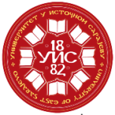 |  | UNIVERSITY OF EAST SARAJEVO |  |  |  |  |  |  |  |  |  | 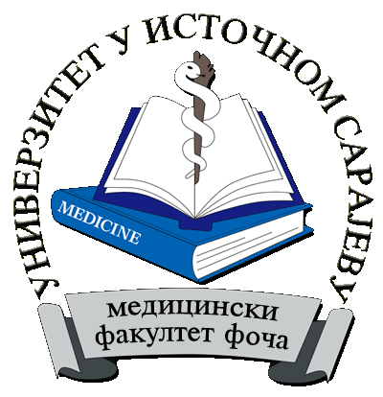
 |  | Study programme | Nursing
II STUDY CYCLE
SUBJECTS |  |  | Lectures per week |  |  |  | Lectures per year |  |  | SSW | Total number of hours per subject |  | ECTS | The requirement for examination
 |  |  | I sem. |  | II sem.
No . | Subject code | NAME OF SUBJECT | L | E | L | E | Lectures | Exercises | Total
1 | ЗЊ-01-1-001-1 | Scientific-research work in health care | 2 | 3 | 0 | 0 | 30 | 45 | 75 | 165 | 240 |  | 8 | -
2 | ЗЊ-01-1-002-1 | Statistical methods in medical science and practice | 2 | 2 | 0 | 0 | 30 | 30 | 60 | 150 | 210 |  | 7 | -
3 | ЗЊ-01-1-003-1 | IT methods in medical science and practice | 2 | 3 | 0 | 0 | 30 | 45 | 75 | 165 | 240 |  | 8 | -
 |  | Elective subjectI | 2 | 2 | 0 | 0 | 30 | 30 | 60 | 150 | 210 |  | 7 | -
 |  | Elective subjectII | 0 | 0 | 2 | 3 | 30 | 45 | 75 | 165 | 240 |  | 8 | -
 |  | Elective subjectIII | 0 | 0 | 2 | 2 | 30 | 30 | 60 | 150 | 210 |  | 7 | -
ЗЊ-01-1-010-2 |  | Diploma paper (master's thesis) | 0 | 0 | 0 | 0 | 0 | 0 | - | 450 | 450 |  | 15
Total number of active teaching |  |  |  |  |  |  | 180 | 225 | 405 | 1395 | 1800 |  | 60
Elective subjectI
(A student listens and takes exam of 1 elective subject which goes into total student workload)
4 | ЗЊ-01-2-004-1 | Ethical principles in medicine and health care | 2 | 2 | 0 | 0 | 30 | 30 | 60 | 150 | 210 | 7 | -
5 | ЗЊ-01-2-005-1 | Patient's quality of life | 2 | 2 | 0 | 0 | 30 | 30 | 60 | 150 | 210 | 7 | -
Elective subjectII
(A student listens and takes exam of 1 elective subject which goes into total student workload)
6 | ЗЊ-01-2-006-2 | The theory of health care and practice | 0 | 0 | 2 | 3 | 30 | 45 | 75 | 165 | 240 | 8 | -
7 | ЗЊ-01-2-007-2 | Pedagogical basics of teaching | 0 | 0 | 2 | 3 | 30 | 45 | 75 | 165 | 240 | 8 | -
Elective subjectIII
(A student listens and takes exam of 1 elective subject which goes into total student workload)
8 | ЗЊ-01-2-008-2 | Interdisciplinary health care | 0 | 0 | 2 | 2 | 30 | 30 | 60 | 150 | 210 | 7 | -
9 | ЗЊ-01-2-009-2 | Interpersonal education in medicine and health care | 0 | 0 | 2 | 2 | 30 | 30 | 60 | 150 | 210 | 7 | -

L – lectures
E– exercises
SSW- self student work

1. | LECTURES | 180
2 | EXERCISES | 225
3 | TOTAL NUMBER OF LECTURES | 405
4 | SELF STUDENT WORK (SSW) | 1395
6 | ECTS | 60
Vice Dean for Teaching

Nedeljka Ivkovic, PhD
_______________________
(signature)

